Epsom & Ewell F.C.
11
v
Bedfont Sports
Saturday, 19th November 2016 – 3.00 p.m.
Good afternoon! We host Bedfont Sports today in a League match and welcome their players, officials and supporters and of course our own regular faces.

Our opponents have become well established at this level since their promotion a few seasons back, and are arguably having their best season to date. Well placed in the league and remaining in the Vase and League Cup, there is every possibility of a season to remember at the Sports Club, which if you’ve not been before is well worth a visit. They will also have an astroturf surface in place by the time we are scheduled to visit in February.

Our last home matches produced mixed results. We were handicapped near the start of our big F.A. Vase encounter with Abbey Rangers by a very harsh sending off and although we took the lead it was a very tough ask to keep it going and we fell to a 3-2 defeat.

Then on Tuesday we defeated Windsor 2-0 in the League here. It was about as comfortable as could be hoped for, with two early goals giving us a cushion we looked very unlikely to give up.

This has moved us up to sixth place in the table and whilst some teams below us, including today’s visitors, can pass us by winning games in hand, we can catch many of those who sit above us, so our position is probably a fair one.

Obviously today’s match is a tough one but it will also be a measure for both teams. We know that to finish in the top four you need to beat the teams around you, of which our opponents are one. For Bedfont Sports, a result against our team would give them an indication of where they stand this season as they know we have been one of the better clubs in the league in recent seasons.

Following this match we have the midweek off and reconvene here in seven days for the visit of A.F.C. Hayes. In the last match programme I mentioned about targeting five wins from these five home matches and so far it’s two out of three. Hopefully that record will have improved further after this match!

We are still in urgent need of both match and player sponsors, so if you can help, or know someone at a local business who might be interested, please have a word with a Committee Member for details. Thank you!

Finally, apologies for the smaller than usual programme today. We have had so many home games that it was just not possible to include all the regular features.

Enjoy the game!

Rich

You can follow us on Facebook: www.facebook.com/epsomandewellfc Twitter: @EEFCOfficial and
Instagram at: www.instagram.com/epsomandewellfc We also have a Youtube channel now!

Cover photos by Gemma Jarman

- Matt Tanton scores the winner at home to SCR on Tuesday 8th November

- Matt Farrell strikes our first goal against Abbey Rangers in the F.A. Vase tie

Cherry Red Records Combined Counties League
Premier Division Table 2016/17
incl Tuesday 15th November | P | W | D | L | F | A | Pts | GD | H | A
Hartley Wintney | 19 | 16 | 2 | 1 | 70 | 19 | 50 | +51 | 18/3 | 10/12
Westfield | 18 | 12 | 4 | 2 | 40 | 16 | 40 | +24 | 18/2 | 1-2
Hanworth Villa | 20 | 12 | 3 | 5 | 36 | 25 | 39 | +11 | 13/12 | 14/1
Knaphill | 19 | 10 | 2 | 7 | 41 | 34 | 32 | +7 | 4-0 | 8/4
Guildford City | 20 | 9 | 4 | 7 | 47 | 42 | 31 | +5 | 17/1 | 2-0
Epsom & Ewell | 17 | 9 | 3 | 5 | 41 | 24 | 30 | +17 | X | X
Horley Town | 16 | 9 | 3 | 4 | 36 | 24 | 30 | +12 | 3-0 | 17/4
Walton & Hersham | 15 | 8 | 5 | 2 | 23 | 13 | 29 | +10 | 4/3 | 1-1
Bedfont Sports | 16 | 9 | 2 | 5 | 34 | 30 | 29 | +4 | 19/11 | 7/2
Camberley Town | 17 | 8 | 2 | 7 | 34 | 20 | 26 | +14 | 0-0 | 1/4
CB Hounslow United | 15 | 8 | 1 | 6 | 30 | 27 | 25 | +3 | 1-5 | 12/11
Colliers Wood United | 18 | 6 | 5 | 7 | 32 | 33 | 23 | -1 | 14/4 | 0-5
Windsor | 20 | 6 | 5 | 9 | 32 | 39 | 23 | -7 | 2-0 | 1-2
North Greenford United | 17 | 6 | 4 | 7 | 35 | 35 | 22 | 0 | 22/4 | 1-2
Abbey Rangers | 18 | 6 | 3 | 9 | 26 | 35 | 21 | -9 | 7-1 | ???
Spelthorne Sports | 16 | 5 | 5 | 6 | 27 | 26 | 20 | +1 | 7/1 | 25/2
AFC Hayes | 17 | 5 | 2 | 10 | 23 | 33 | 17 | -10 | 26/11 | 28/1
Farnham Town | 16 | 5 | 1 | 10 | 25 | 37 | 16 | -12 | 25/3 | 2-1
Raynes Park Vale | 20 | 4 | 4 | 12 | 26 | 43 | 16 | -17 | 27/12 | 1-1
Sutton Common Rovers | 16 | 4 | 3 | 9 | 18 | 30 | 15 | -12 | 2-1 | 2/1
Chertsey Town | 17 | 4 | 3 | 10 | 18 | 45 | 15 | -27 | 17/12 | 11/2
Bedfont & Feltham | 19 | 3 | 3 | 13 | 23 | 54 | 12 | -31 | 21/1 | 9-2
Badshot Lea | 18 | 3 | 1 | 14 | 22 | 55 | 10 | -33 | 4/2 | 4-1

Lucky Day? – 19th November
Played 12 - W 3 D 0 L 9 - For 14 Against 34 - PPG 0.75 - Very Poor
Our Club record against Bedfont Sports
Played 9 - W 5 D 2 L 2 - F 13 A 10 - PPG 1.89 - Good
Our Largest wins and losses against our opponent
9th October 2012 - W 3-0 - Combined Counties League Cup (A)
18th August 2012 - L 0-4 - Combined Counties League (H)
Their Last Visit
Saturday 13th February 2016 - W 1-0 - Combined Counties League

First Eleven Appearances 2016/17 - (max 23)
Name | Debut | 2016/17 |  |  |  | Career Totals
 |  | App | Sub | Total | Goals | App | Sub | Total | Goals
CLARK-GLEAVE Charlie | 23/08/2016 | 1 | 2 | 3 | 0 | 1 | 2 | 3 | 0
COOPER-SMITH Daryl | 03/01/2015 | 18 | 1 | 19 | 17 | 48 | 9 | 57 | 37
DEAN Dan | 02/08/2014 | 15 | 2 | 17 | 0 | 83 | 6 | 89 | 2
EACOTT Michael | 02/08/2014 | 18 | 0 | 18 | 0 | 103 | 1 | 104 | 0
FARRELL Matt | 02/08/2014 | 22 | 0 | 22 | 11 | 108 | 4 | 112 | 29
FERDINANDO Matt | 20/09/2014 | 11 | 3 | 14 | 2 | 64 | 9 | 73 | 16
GALLAGHER Jordan | 07/08/2016 | 8 | 12 | 20 | 5 | 8 | 12 | 20 | 5
GRIFFIN Reisse | 08/08/2015 | 20 | 2 | 22 | 2 | 48 | 8 | 56 | 4
HASTINGS Craig | 08/08/2015 | 15 | 5 | 20 | 1 | 52 | 9 | 61 | 1
HEAGNEY Adam | 16/08/2016 | 13 | 3 | 16 | 0 | 13 | 3 | 16 | 0
HENDRY Rob | 08/08/2015 | 15 | 5 | 20 | 3 | 45 | 16 | 61 | 15
MCKAY Alex | 20/12/2008 | 14 | 2 | 16 | 2 | 122 | 32 | 154 | 10
NEALE Tom* | 13/10/2015 | 6 | 5 | 11 | 7 | 22 | 24 | 46 | 17
NORTH Rhys* | 16/08/2015 | 2 | 2 | 4 | 0 | 19 | 9 | 28 | 1
NWACHUKWU Jason | 01/10/2016 | 3 | 5 | 8 | 0 | 3 | 5 | 8 | 0
PANAYIOTOU Savvas | 03/01/2015 | 17 | 3 | 20 | 0 | 49 | 11 | 60 | 7
PRICE Matt* | 23/08/2016 | 2 | 0 | 2 | 1 | 2 | 0 | 2 | 1
ROBINSON Sam* | 22/10/2011 | 7 | 1 | 8 | 1 | 61 | 6 | 67 | 14
ROSE Daniel | 25/10/2016 | 1 | 1 | 2 | 0 | 1 | 1 | 2 | 0
SALEH Mennar* | 24/09/2016 | 0 | 2 | 2 | 0 | 0 | 2 | 2 | 0
SMITH Matt | 08/08/2009 | 0 | 1 | 1 | 1 | 91 | 44 | 135 | 11
TANTON Matt | 02/08/2014 | 19 | 1 | 20 | 1 | 76 | 5 | 81 | 3
TAYLOR James | 26/08/2013 | 17 | 3 | 20 | 0 | 103 | 15 | 118 | 6
THOMPSON Elliott | 09/02/2016 | 3 | 0 | 3 | 1 | 7 | 9 | 16 | 1
TURPIE Alistair | 31/03/2016 | 5 | 1 | 6 | 0 | 7 | 1 | 8 | 0
WATRET Jack* | 02/08/2016 | 1 | 0 | 1 | 0 | 1 | 0 | 1 | 0
* player has left the club

Latest Results and Fixtures
Combined Counties League – Monday 7th November
Abbey Rangers | 3-3 | Knaphill
Combined Counties League – Tuesday 8th November
Camberley Town | 0-1 | Guildford City
Epsom & Ewell | 2-1 | Sutton Common Rovers
Combined Counties League – Wednesday 9th November
Colliers Wood United | 2-2 | Horley Town
Buildbase F.A. Vase – Second Round – Saturday 12th November
Highworth Town | 1-3 | Knaphill
Bedfont Sports | 2-0 | Haywards Heath Town
Camberley Town | 0-4 | Southall
Combined Counties League – Saturday 12th November
Chertsey Town | 3-3 | Bedfont & Feltham
Horley Town | 4-1 | North Greenford United
Raynes Park Vale | 1-3 | Westfield
Windsor | 0-5 | Hanworth Villa
Buildbase F.A. Vase – Second Round – Sunday 13th November
Epsom & Ewell | 2-3 | Abbey Rangers
Sutton Common Rovers | 2-1 | Sporting Club Thamesmead
Buildbase F.A. Vase – Second Round – Tuesday 15th November
Hartley Wintney | 1-2 | Melksham Town
Walton & Hersham | 2-2+ | Glebe
Glebe won 3-1 on penalties
Surrey Senior Cup Second Round – Tuesday 15th November
Ashford Town (Mx) | 0-1 | Knaphill
Combined Counties League Cup Third Round – Tuesday 15th November
Banstead Athletic | 4-4+ | Westfield
Banstead Athletic won 4-2 on penalties
Combined Counties League – Tuesday 15th November
AFC Hayes | 1-4 | Bedfont & Feltham
Epsom & Ewell | 2-0 | Windsor
Hanworth Villa | 2-1 | Camberley Town
Horley Town | 4-1 | Guildford City
North Greenford United | 3-2 | Badshot Lea
Latest Results and Fixtures
Combined Counties League Cup Second Round – Saturday 19th November
Worcester Park | V | Cove
Combined Counties League – Saturday 19th November
AFC Hayes | V | Hartley Wintney
Bedfont & Feltham | V | Walton & Hersham
Camberley Town | V | Raynes Park Vale
Chertsey Town | V | Windsor
Colliers Wood United | V | Badshot Lea
Epsom & Ewell | V | Bedfont Sports
Guildford City | V | CB Hounslow United
North Greenford United | V | Knaphill
Spelthorne Sports | V | Horley Town
Sutton Common Rovers | V | Farnham Town
Westfield | V | Abbey Rangers
Combined Counties League Cup Second Round – Monday 21st November
Sutton Common Rovers | V | Bedfont Sports
Combined Counties League Cup Third Round – Tuesday 22nd November
Farnham Town | V | Camberley Town
Combined Counties League – Tuesday 22nd November
CB Hounslow United | V | AFC Hayes
Westfield | V | Horley Town
Combined Counties League – Wednesday 23rd November
Guildford City | V | Colliers Wood United
Combined Counties League – Saturday 26th November
CB Hounslow United | V | Westfield
Chertsey Town | V | Bedfont Sports
Epsom & Ewell | V | AFC Hayes
Farnham Town | V | Badshot Lea
Hanworth Villa | V | Spelthorne Sports
Hartley Wintney | V | Guildford City
Horley Town | V | Camberley Town
Knaphill | V | Sutton Common Rovers
Raynes Park Vale | V | Abbey Rangers
Walton & Hersham | V | North Greenford United
Windsor | V | Colliers Wood United

From behind the goal
Epsom & Ewell 2-3 Abbey Rangers
Buildbase F.A. Vase - Second Round - Sunday 13th November 2016

More Vase frustration as another campaign ends in controversy

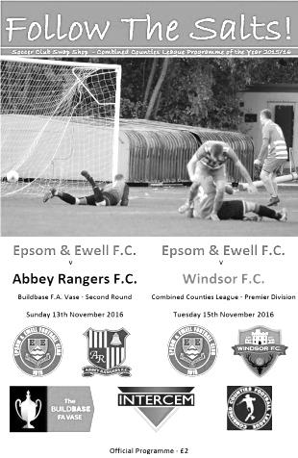
I really don't know what it is about the Vase. Maybe it is some sort of penance for reaching the first ever Final in 1975 that we seem destined to get the rough end of any decisions in every other Vase match since. This was most definitely the case here as a poorly officiated match was affected from the start by a controversial sending off and by the end there was so much confusion caused by a number of mystifying and inconsistent decisions which led to both sets of teams appealing for everything just on the off chance of getting something.

Captain Dan Dean returned to the starting line up with Alex McKay moving back into midfield and Jordan Gallagher dropping to the bench following our 2-1 win over Sutton Common Rovers on Tuesday and the opening exchanges were promising. Matt Ferdinando was upended on the edge of the box in the first twenty seconds but for some reason didn't take the subsequent set piece and Rob Hendry sent the kick over the bar.

Just as we were all getting settled in for an entertaining encounter the game changed when our full back Reisse Griffin was sent off. I didn't have a great view of the incident, so have spoken to about a dozen people on this now and there were a number of differing views. What appears to have happened is that there was a foul by a visiting player on our man who retaliated and this was why he was sent off. The original foul was missed, indeed a throw on was the eventual outcome once the game had restarted, but I fail to understand why a referee, having clearly not had a great view to start with as he obviously missed the original foul, would not wonder why it was that our player felt the need to retaliate so early in a match. Players just don't do that sort of thing, especially so early in the match and I can also confirm that this is the first red card our man has received in his time with us.

Whilst obviously not condoning the retaliation, no matter what the provocation was, this looked to be a case of two offending parties who should have received equal punishment, but the most pivotal game in our season changed in that one instant because the official missed half of the incident, despite being fairly close to it when it happened.

At first it didn't appear to matter. Our players, possibly fuelled by the injustice, continued to produce the more dangerous moments, although when we took the lead it was largely due to an act of generosity from a former player, Joe Paris, recently transferred to Abbey from Hartley Wintney. His back pass was anticipated and intercepted by Daryl Cooper-Smith who held the ball up for Matt Farrell to strike the ball into the net from 12 yards out and give us the lead in the 17th minute.

We continued to push forward and Craig Hastings was unfortunate to flick a McKay long throw just beyond the frame of the goal, but as the half went on we found ourselves doing much of the defending. What made things even more concerning for spectators and players alike was that you had no idea which challenge would be completely ignored and which would be penalised. One such occurrence came when Rob Hendry went for the ball in midfield, then pulled out, only to witness a classic swan dive from the visiting player right in front of the benches. The referee decided to speak to the player, indicating that he had obviously seen the incident, yet chose to do nothing.

Three minutes later after we conceded a foul, Matt Ferdinando, by this time playing at right back in relief of the departed Griffin, received a two minute lecture and a yellow card just for kicking the ball away

moments after the whistle had blown! Even that would have been understandable had yellows followed in the second half when the visitors did it twice themselves, but they wouldn't be given.

The Abbey pressure resulted in a penalty in the 40th minute. Ferdinando jumped for the ball while the attacker made no effort and our man went over the top of him. These sort of decisions are hardly ever given that way and even the visiting supporters must have been slightly surprised to see the award given, although they understandably appealed for it. Patric Ruzicka stepped up to take the kick but Michael Eacott guessed correctly and made a fine save to his right. Despite this, they then drew level within two minutes after a shot by Ruzicka from the right hand channel seemed to evade everyone and nestled in the far corner of the net.

Despite being level at this time, this was a very worrying situation. With our lead gone and the decisions we had already seen, this was going to be a very difficult half and so it proved. It started when Hendry was pulled up for a foul at the start of the half, despite never having made contact with the player and a few minutes later he was then booked for a foul, accompanied by the subsequent lecture. From the free kick the visitors missed the target from close range and we had to be alert to block another free kick at the far post as the visitors started to make their numerical advantage count.

We made a change as James Taylor came on for the frustrated Hendry and we pushed Ferdinando forward where he could have more of an effect on the play and he won a free kick when cynically taken out by a defender just as he broke past him. Needless to say no card was issued, and worse was to follow as with all our big men forward Ferdinando's free kick in the 67th minute was claimed by Liam Stone in the visitors goal who launched an enormous clearance over Matt Tanton to Ruzicka who put them ahead with a good low shot from twenty yards that hit the near post and ended up in the opposite side netting. Clearly luck wasn't going to be on our side either, but it was a great strike.

Regrettably we then conceded again six minutes later and in similar circumstances as another of our free kicks was too close to Stone and he found a team mate who then found Ruzicka in space and he calmly beat Eacott to complete his hat trick. The game looked over at this point but a 35 yard free kick from substitute Gallagher was placed in a really difficult place and Cooper-Smith got the faintest of touches from 8 yards out as the ball found the far corner of the net with 75 minutes played.

We raised our game in an attempt to force extra time but Farrell picked up a yellow card after making a perfectly legitimate challenge before a visiting defender finally found his way into the book after cynically bringing down Ferdinando in flight once again. It was clever defending really as the foul was some way out from goal and we were unable to do much with it.

In the final minute of normal time we nearly equalised. A good ball in led to a massive scramble in the area with two well struck shots being blocked by committed defenders. There were shouts of handball, and I'm reliably informed that the first block was with a hand, but to be fair to the referee and Assistants, it was all such close range stuff with so many people involved and so much going on in there that it would be very difficult to have seen anything for certain. Maybe on another day the ball would have found its way into the net and I could have been writing about an incredible escape but it was not to be.

For the neutral in the attendance of 110, this may well have been a very entertaining match. It was competitive throughout and both sets of players were fully committed to their cause. Regrettably for the home supporters the overriding memory of this match will be the way we were handicapped before the match had even got going by an official that frankly appeared out of his depth for such an important contest. That will not be forgotten for many years.

Epsom and Ewell: Michael Eacott, Reisse Griffin, Matt Tanton, Craig Hastings,
Dan Dean ©, Alex McKay, Rob Hendry, Matt Farrell, Daryl Cooper-Smith,
Savvas 'Agi' Panayiotou, Matt Ferdinando

Subs: James Taylor for Hendry (62), Jordan Gallagher for Panayiotou (73)
Jason Nwachukwu for Tanton (80)

From behind the goal
Epsom & Ewell 2-0 Windsor
Combined Counties League - Premier Division - Tuesday 15th November 2016

Gallagher shines in comfortable Salts victory

With both teams coming into this match on the back of tough defeats, it was our boys who were able to respond the better and eased to victory at High Road, moving up to sixth place in the League table as a result.

Not surprisingly, following a match just two days earlier in which we had competed with ten players for 80 minutes, we made some rotations. Ali Turpie came in for Michael Eacott and James Taylor came in at right back for Reisse Griffin, while in midfield Jason Nwachukwu came in for Alex McKay with Agi Panayiotou sitting deeper in McKay's role and Jordan Gallagher starting in place of Rob Hendry. It could be argued that Gallagher was the difference between the two teams, especially in the first half, scoring once and creating the second of our two goals.

The opening encounters were even although it was clear, even from the start of the match that Gallagher was getting a lot of space on the left. He set up Daryl Cooper-Smith for a powerful low shot from the edge of the area in the 16th minute but the strike was well saved by Hugo Sobte the visitors custodian. Two minutes later Gallagher again got free on the left but over hit the cross with Cooper-Smith and Matt Ferdinando coming in.

We were doing slightly more of the attacking but Windsor hit us with a counter attack and Turpie made a brave save at the feet of their striker. We then went ahead in the 23rd minute when Nwachukwu made a powerful run directly at goal. He beat two men and as others converged on him, had the presence of mind to lay the ball off to Gallagher who had the relatively simple job of curling the ball around the exposed Sobte into the net from 12 yards.

The visitors responded and a dangerous ball went across the face of our goal but we made it 2-0 in the 27th minute when Gallagher turned his man inside out before delivering a peach of a cross for Cooper-Smith to score one of his easier goals of the season as he headed in from just four yards out.

The rest of the half contained very little in the way of goalmouth action and it was clear by half time that the difference between the two sides was in the final third. Windsor, on a run where they had just one point from their previous six matches looked low on confidence even with the returning Rob Lazarczuk in their ranks and the game looked all over by half time, even though the lead was only two goals.

Ferdinando struck powerfully just over the bar in the 51st minute after a good move and was really unlucky with a great header of a deep Cooper-Smith cross almost from the corner flag. He headed the ball back across goal and it was one of those slow motion moments where no one knew whether it would creep in at the far post, but it went inches wide instead.

To be fair to Windsor they made a couple of changes and started to hit a longer ball, one of which forced Turpie to tip the ball over for a corner. This heralded a small spell of pressure and Turpie was grateful to see an unmarked header at the far post aimed straight into his arms. We made our first substitution as Craig Hastings was replaced by the fit again Adam Heagney and Taylor moved alongside Dan Dean at the back. However, the visitors kept pressing and a deep left wing cross was headed back across goal but the Windsor striker was at full stretch and was unfortunate to see his attempt hit the far post and bounce away.

This was a bit of a wake up call for our boys and Cooper-Smith set up Gallagher but he fired wide. Turpie tipped another long ball over for a corner and we should have extended our lead in the 79th minute. Nwachukwu held the ball up really well before setting Farrell up. With everyone expecting a shot, he laid the ball off to the unmarked Gallagher who chose to go to the keeper's left with his shot. Sobte saved the ball but parried it to the feet of substitute Reisse Griffin who put the ball over the bar of the open goal from just 8 yards out!

Four minutes later Farrell intercepted a poor pass in midfield and ran at the goal, drawing the defender over. He set up Cooper-Smith but his low shot from the edge of the box was turned around the post by the diving Sobte. A few minutes later Nwachukwu was fouled on the edge of the box but Hendry's free kick came at a good height at was well caught.

As the match went into the final minutes we had two virtually identical incidents. For those of you old enough to remember Paul Gascoigne just being unable to reach a square ball in Euro 96 against Germany, these were very similar. Firstly, Nwachukwu struck from the left side across goal inches ahead of Cooper-Smith and just after this Cooper-Smith drove the ball across goal from the right hand side with Farrell this time being unable to reach it. Both of our players ended up in the net but I'm told that doesn't count for much!

We had an unfortunate incident in injury time when Cooper-Smith and Jamie Di Guiseppe got tangled up with each other in chasing a through ball and the referee felt the need to book both for what appeared a genuine accident. That aside, I should report in the interests of balance that the match was very well controlled from start to finish by the officiating team.

Epsom and Ewell: Ali Turpie, James Taylor, Matt Tanton, Craig Hastings, Dan Dean ©, Savvas 'Agi' Panayiotou, Jordan Gallagher, Matt Farrell, Daryl Cooper-Smith,
Jason Nwachukwu, Matt Ferdinando
Subs: Adam Heagney for Hastings (67), Reisse Griffin for Ferdinando (73)
Rob Hendry for Gallagher (84)

Bedfont Sports F.C. – History
Bedfont Sports Club was founded in 2002, when with considerable help from the local Council a lease was taken out on the near derelict Hatton Road Recreation Ground.

The only building on the site was refurbished to allow use as a bar and clubhouse on the ground floor and changing rooms on the upper one. Most of this work was carried out or supervised by the Chairman Dave Reader. Much work was also done to the playing area to provide playable pitches for Bedfont Sports on Saturdays and Bedfont Sunday, one of the oldest Sunday teams in Middlesex, on Sundays. To give the Club a junior section Bedfont Eagles, formed in 1978, joined the two adult Clubs a short time later.

Bedfont Sports started in the Hounslow and District League for two seasons and then joined the Middlesex County Football League, this being a feeder League to Step 5. More work was needed to enable the team to play in the Premier Division of the MCFL to which they gained promotion in 2004/05. After many ups and downs promotion was finally achieved to the Combined Counties Reserve Division in season 2008/09.

During this time applications were made to the F A and the Football Foundation for funds to enable Flood Lights and a new Dressing Room block to be built together with a 3G five a side pitch. This finally materialised in 2010/11 to give the state of the art complex now available at Bedfont Sports.

In the Combined Counties League Bedfont gained promotion to the Premier Division in season 2011/12 and have spent the past few seasons consolidating that position.

Permanent fencing now surrounds the ground and a 150 seater stand has been installed with a full 3g Astroturf surface to be installed in the next few weeks.

Bedfont Sports is a true Community Club catering for 16 Junior Teams, a girls team, a youth section and two adult teams on a Saturday and Sunday.

The Youth Section is particularly vibrant playing in the Ryman Youth League and having won the Combined Counties under 18 Cup twice in the last four seasons. Players from the Youth section make the step up to adult football, at least five from that section being regulars in the first team at present.

A successful kick boxing club use the facilities together with a boxing club, a rugby team and three darts teams.

The bar area has been recently refurbished as a Sports bar with televisions on all walls.

A Club such as Bedfont Sports could not exist without sponsors so a big thank you to them and to the volunteers who give their time on match days and to the marking and upkeep of the ground and facilities.

Combined Counties League Premier Division Opponents
All-time Records
incl Tuesday 15th November | P | W | D | L | F | A | PPG | GD | Best  Win | Worst  Loss
Bedfont & Feltham | 1 | 1 | 0 | 0 | 9 | 2 | 3.00 | +7 | 9-2 | X
Spelthorne Sports* | 5 | 4 | 1 | 0 | 15 | 6 | 2.60 | +9 | 6-2 | X
Sutton Common Rovers | 11 | 9 | 1 | 1 | 29 | 13 | 2.55 | +16 | 4-0 | 1-4
Horley Town | 29 | 20 | 5 | 4 | 65 | 30 | 2.24 | +35 | 6-0 | 1-3
Colliers Wood United | 22 | 14 | 2 | 6 | 45 | 33 | 2.00 | +12 | 4-0 | 0-5
Abbey Rangers | 3 | 2 | 0 | 1 | 10 | 4 | 2.00 | +7 | 7-1 | 2-3
Westfield | 19 | 11 | 3 | 5 | 40 | 31 | 1.89 | +9 | 6-1 | 0-4
Bedfont Sports | 9 | 5 | 2 | 2 | 13 | 10 | 1.89 | +3 | 3-0 | 0-4
Farnham Town | 14 | 8 | 2 | 4 | 25 | 23 | 1.86 | +2 | 3-1 | 1-4
Knaphill | 7 | 4 | 1 | 2 | 15 | 8 | 1.86 | +3 | 4-0 | 1-2
Guildford City | 17 | 10 | 1 | 6 | 34 | 22 | 1.82 | +12 | 5-1 | 1-5
Hanworth Villa | 15 | 8 | 3 | 4 | 38 | 26 | 1.80 | +12 | 5-0 | 1-4
Raynes Park Vale | 27 | 13 | 6 | 8 | 58 | 37 | 1.67 | +21 | 6-1 | 0-2
Badshot Lea | 18 | 8 | 3 | 7 | 35 | 34 | 1.67 | +1 | 4-1 | 0-4
Walton & Hersham | 50 | 24 | 10 | 16 | 101 | 97 | 1.64 | +4 | 6-0 | 0-8
Camberley Town* | 89 | 38 | 22 | 28 | 158 | 123 | 1.52 | +35 | 9-1 | 0-4
Hartley Wintney | 10 | 4 | 3 | 3 | 25 | 17 | 1.50 | +8 | 5-0 | 2-4
Windsor | 49 | 19 | 12 | 18 | 90 | 90 | 1.41 | -2 | 4-0 | 0-6
Chertsey Town | 47 | 17 | 5 | 25 | 70 | 86 | 1.19 | -16 | 3-0 | 0-7
AFC Hayes | 8 | 2 | 2 | 4 | 16 | 15 | 1.00 | +1 | 7-0 | 0-3
North Greenford United | 11 | 3 | 2 | 6 | 15 | 20 | 1.00 | -5 | 3-0 | 1-4
CB Hounslow United | 2 | 0 | 0 | 2 | 2 | 7 | 0.00 | -5 | X | 1-5
* includes one abandoned match v Camberley and one loss on penalties v Spelthorne

Centre page for results

Centre page for results

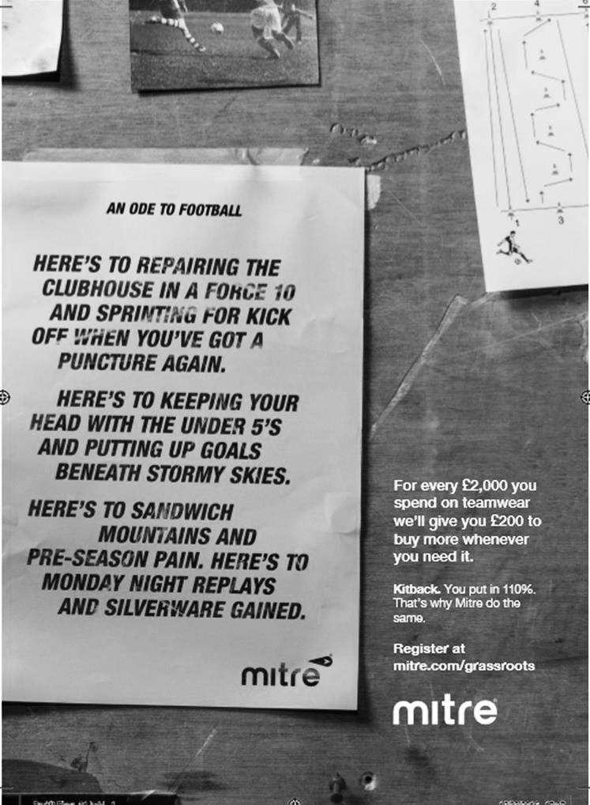

Surrey Senior Cup
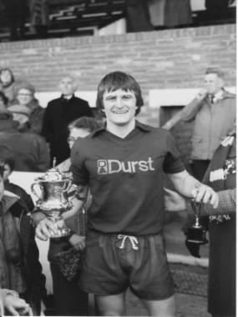
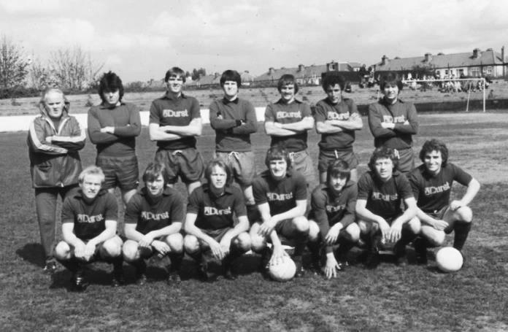
First Round
Abbey Rangers | 4-3 | AFC Croydon Athletic
Whyteleafe | 5-4 | Westfield
Second Round
Met Police | V | Kingstonian
Ashford Town (Mx) | 0-1 | Knaphill
Woking | 4-0 | Walton Casuals
Whyteleafe | 6/12 | Colliers Wood United
Guildford City | 30/11 | Horley Town
Egham Town | 3-0 | Corinthian Casuals
Godalming Town | 6/12 | Merstham
Molesey | 0-1 | Leatherhead
Raynes Park Vale | 6/12 | Sutton United
Sutton Common Rovers | 28/11 | Camberley Town
Dorking Wanderers | 6/12 | South Park
Badshot Lea | 29/11 | Farnham Town
Walton & Hersham | 22/11 | Croydon
Carshalton Athletic | 12/12 | Tooting & Mitcham United
Chertsey Town | 29/11 | Abbey Rangers
Epsom & Ewell | 6/12 | Chipstead

Buildbase F.A. Vase
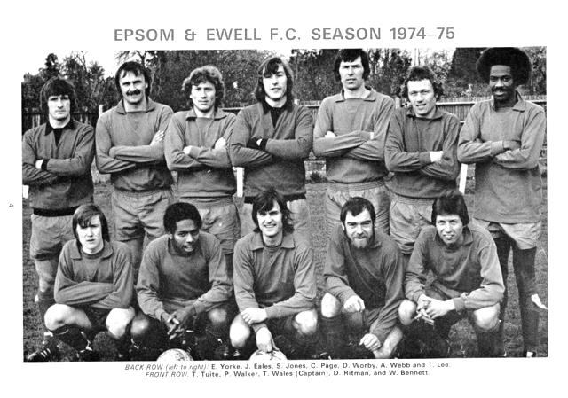

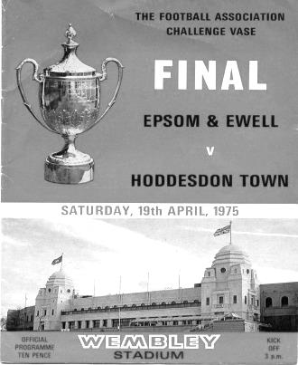
Second Round – Southern Clubs only – 34 of the 64 ties
Wadham Lodge | 0-3 | Ely City
Rothwell Corinthians | 1-2 | Tring Athletic
Leverstock Green | 1-2 | Welwyn Garden City
St Margaretsbury | 4-2+ | Stanway Rovers
Newport Pagnell Town | 2-1 | Broadfields United
Berkhamsted | 5-2 | Hullbridge Sports
Gorleston | 2-1 | Northampton Sileby Rangers
Cockfosters | 1-2 | Wembley
Peterborough Sports | 5-3 | Biggleswade
London Colney | 3-0 | Holmer Green
Biggleswade United | 1-1+ r 1-1+ 4-5p | Sun Sports
FC Romania | 2-0 | Ipswich Wanderers
Hoddesdon Town | 2-0 | Thetford Town
Basildon United | 3-2 | Felixstowe & Walton United
Eastbourne Town | 2-1 | Ashford United
Sutton Common Rovers | 2-1 | Sporting Club Thamesmead
Newhaven | 2-1 | Ascot United
Bedfont Sports | 2-0 | Haywards Heath Town
Eastbourne United | 0-1 | Crowborough Athletic
Walton & Hersham | 2-2+ lost 1-3p | Glebe
Camberley Town | 0-4 | Southall
Croydon | 2-1 | Andover Town
Corinthian | 3-2 | Alresford Town
Lancing | 1-7 | Horsham YMCA
Chichester City | 3-1+ | Canterbury City
Highworth Town | 1-3 | Knaphill
Epsom & Ewell | 2-3 | Abbey Rangers
Portland United | 1-2 | Blackfield & Langley
Shaftesbury Town | 1-3 | Team Solent
Brimscombe & Thrupp | 2-2+ r0-5 | Bradford Town
Bristol Manor Farm | 2-1 | Odd Down
Moneyfields | 0-4 | Thatcham Town
Cullompton Rangers | 1-1+ r2-3 | Bemerton Heath Harlequins
Hartley Wintney | 1-2 | Melksham Town
Gillingham Town | 0-1 | Exmouth Town
Buckland Athletic | 1-0 | Newport (IW)
1-0
EL Records Premier Challenge Cup
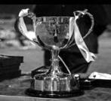
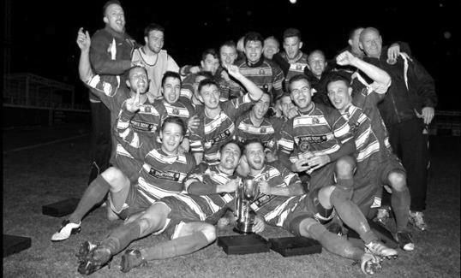
First Round
Redhill | 4-0 | Bedfont & Feltham
Match played at Bedfont & Feltham F.C.
Spelthorne Sports | 1-4 | Sutton Common Rovers
Knaphill | 0-2 | Camberley Town
Worcester Park | 2-1 | Dorking
Epsom & Ewell | 1-0 | Abbey Rangers
Westfield | 3-2 | North Greenford United
Cobham | 3-2+ | Bagshot
CB Hounslow United | 3-4 | Farnham Town
South Park Reserves | 1-4 | Balham
Second Round
Hanworth Villa | 2-4+ | Epsom and Ewell
AFC Hayes | 3-4 | Balham
Epsom Athletic | 1-5 | Windsor
Sutton Common Rovers | 21/11 | Bedfont Sports
Raynes Park Vale | 2-0 | Colliers Wood United
Frimley Green | 1-2 | Banstead Athletic
Westfield | 8-4+ | Redhill
Staines Lammas | 0-1 | Farnham Town
Worcester Park | 19/11 | Cove
Badshot Lea | 0-5 | Guildford City
Chertsey Town | 1-2 | Camberley Town
Cobham | 1-3 | Chessington & Hook United
Hartley Wintney | 4-0 | AC London
Horley Town | 2-2+ | Sheerwater
Horley Town won 5-4 on penalties
Walton & Hersham | 5-1 | Eversley & California
Ash United | 2-0 | Farleigh Rovers
Third Round
Banstead Athletic | 4-4+ | Westfield
Banstead Athletic won 4-2 on penalties
SCR / Bedfont Sports | V | Walton & Hersham
Farnham Town | V | Camberley Town
Ash United | 0-2 | Windsor
Raynes Park Vale | 2-1 | Hartley Wintney
Guildford City | 2-1 | Balham
Horley Town | 2-0 | Chessington & Hook United
Worcester Park / Cove | V | Epsom & Ewell

CCL Premier Division Club Directory
ABBEY RANGERS Telephone: 01932-422962 - Ground: Addlestone Moor, Addlestone, Surrey KT15 2QH - Colours: Black & White Stripes/Black/Black

A.F.C. HAYES Telephone: 0208-845-0110 - Ground: Farm Park, Kingshill Avenue, Hayes, Middx. UB4 8DD - Colours: Blue and White Stripes/Blue/Blue

BADSHOT LEA Telephone: 01252-320385 - Ground: Ash United FC, Shawfield Stadium, Youngs Drive, Shawfields Road, Ash, Hampshire. GU12 6RE - Colours: Claret/White/Claret

BEDFONT & FELTHAM Telephone: 0208 890 7264 - Ground: The Orchard, Hatton Road, Bedfont, Middx TW14 9QT - Colours: Yellow & Blue/Blue/Blue

BEDFONT SPORTS Telephone: 0208-831-9067 - Ground: Bedfont Sports Club, Hatton Road, Bedfont, Middx TW14 8JA - Colours: Red & Black Hoops/Black/Red & Black Hoops

CAMBERLEY TOWN Telephone: 01276-65392 - Ground: Krooner Park, Wilton Road, Camberley, Surrey. GU15 2QW - Colours: Red & White Stripes/Blue/Red

CB HOUNSLOW UNITED Telephone: 0208 890 7264 - Ground: The Orchard, Hatton Road, Bedfont, Middx TW14 9QT - Colours: Green/Black/Green

CHERTSEY TOWN Telephone: 01932-561774 - Ground: Alwyns Lane, Chertsey, Surrey. KT16 9DW - Colours: Royal Blue & White Stripes/Royal Blue/Royal Blue

COLLIERS WOOD UNITED Telephone: 0208-942 8062 - Ground: Wibbandune Sports Ground, Robin Hood Way, Wimbledon. SW20 0AA - Colours: Blue & Black Stripes/Black/Black
EPSOM & EWELL Telephone: 01737-553250 - Ground: Chipstead FC, High Road, Chipstead, Surrey. CR5 3SF - Colours: Royal Blue & White Hoops/Royal Blue/Royal Blue

FARNHAM TOWN Telephone: 01252-715305 Ground: Memorial Ground, Babbs Mead, West Street, Farnham, Surrey. GU9 7DY Colours: - Claret & Sky Blue /White/ Claret & Sky Blue

GUILDFORD CITY Telephone: 01483-443322 - Ground: The Spectrum, Parkway, Guildford, Surrey. GU1 1UP - Colours: Red & White Stripes/Black/Black

HANWORTH VILLA Telephone: 0208-831-9391 - Ground: Rectory Meadows, Park Road, off Hounslow Road, Hanworth, Middlesex. TW13 6PN - Colours: Red & White Stripes/Black/Black

HARTLEY WINTNEY Telephone: 01252-843586 - Ground: Memorial Playing Fields, Green Lane, Hartley Wintney, Hants RG27 8DL - Colours: Orange & Black/ Orange /Orange

HORLEY TOWN Telephone: 01293-822000 - Ground: The New Defence, Anderson Way, Court Lodge Road, Horley, Surrey. RH6 8SP - Colours: Claret & Sky Blue/Claret/Claret

KNAPHILL Telephone: 01483-475150 - Ground: Brookwood Country Park, Redding Way, Lower Guildford Road, Knaphill, Surrey. GU21 2AY - Colours: Red/Black/Red

NORTH GREENFORD UNITED Telephone: 0208 422 8923 - Ground: Berkeley Fields, Berkeley Avenue, Greenford, Middx UB6 0NX - Colours: Royal Blue & White/Royal Blue/Royal Blue

SUTTON COMMON ROVERS Telephone: 01932-866386 - Ground: Sutton United FC, Gander Green Lane, Sutton, Surrey SM1 2EY - Colours: Yellow/Black/Black

RAYNES PARK VALE Telephone: 020-8540-8843 - Ground: Prince Georges Playing Field, Grand Drive, Raynes Park, London. SW20 9NB - Colours: Blue/Blue/Red

SPELTHORNE SPORTS Telephone: 01932-961055 - Ground: Spelthorne Sports Club, Staines Road, Ashford Common, Ashford, Middx. TW15 1RY - Colours: Light & Dark Blue/Dark Blue/Light Blue

WALTON & HERSHAM Telephone: 01932 245263 - Ground: Stompond Lane, Walton on Thames, Surrey KT12 1HF - Colours: Red/Red/Red

WESTFIELD Telephone: 01483-771106 - Ground: Woking Park, Kingfield Road, Woking, Surrey. GU22 9BA - Colours: Yellow/Black/Black

WINDSOR Telephone: 01753-860656 - Ground: Stag Meadow, St Leonards Road, Windsor, Berks SL4 3DR - Colours: Red/Red/Red

Player Sponsorship
Here is the current list for the 2016/17 season showing all of our players and Management that are currently available for sponsorship.

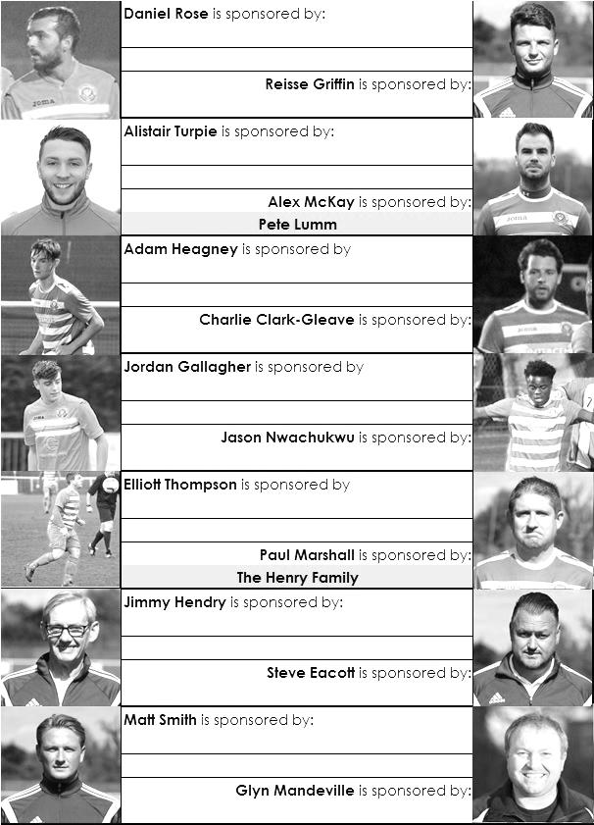

Sponsorship costs just £40 and it is easy to do. Just select a player who has not been previously sponsored and let a Committee Member know that you would like to sponsor them. Beware though. Until we have received the money it is possible for someone to jump in front of you, so don’t delay, sponsor today!
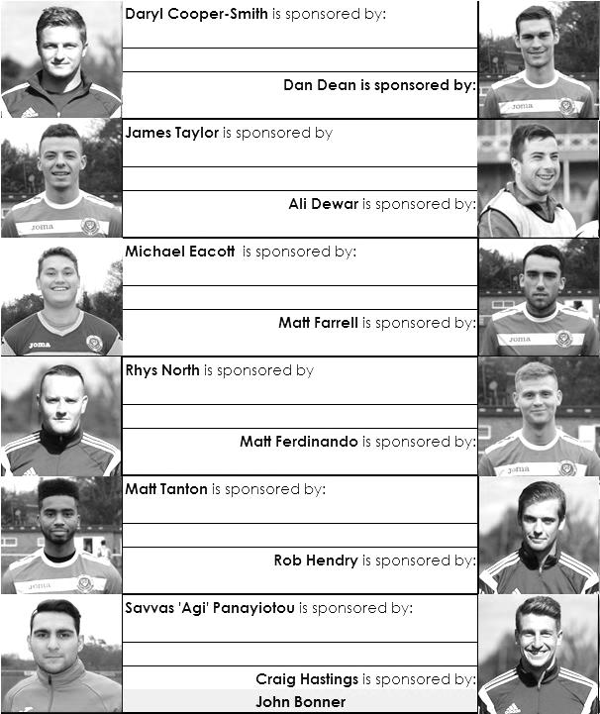

Match and Ball Sponsorships – 2016/17
Opponent | Date | Match Sponsor | Ball Sponsor
Gravesham Borough | 07/08/16 | Club President - Stella Lamont
Gravesham Borough | 07/08/16 | Relocation Committee Member - Mike Lovett
CB Hounslow United | 16/08/16 | EEFC Management Committee
Abbey Rangers | 23/08/16 | Steve & Geoff Dyke
Horley Town (11.30am) | 29/08/16 | In Memory of Chris Henry
Abbey Rangers (LC) | 06/09/16 | Paul Merritt
Camberley Town | 10/09/16 | Building Shop Ltd
Knaphill | 24/09/16 | EEFC Holding Company Director – Pete Lumm
Bridon Ropes (FAV) | 22/10/16 | George and Joseph Saunders
Sutton Common Rovers | 08/11/15 | Alex McKay Senior
Abbey Rangers (FAV) | 13/11/16 | EEFC Holding Company Director – Dave Ellins
Windsor | 15/11/16 | In Memory of Wally Dyke
Bedfont Sports | 19/11/16 | John Bonner
AFC Hayes | 26/11/16
Chipstead (SSC) | 06/12/16
Hanworth Villa | 13/12/16
Chertsey Town | 17/12/16
Raynes Park Vale (11.30am) | 27/12/16
Spelthorne Sports | 07/01/17
Guildford City | 17/01/17
Bedfont & Feltham | 21/01/17 | Programme Editor - Richard Lambert
Badshot Lea | 04/02/17
Westfield | 18/02/17
Walton & Hersham | 04/03/17
Hartley Wintney | 18/03/17
Farnham Town | 25/03/17
Colliers Wood United (1pm) | 14/04/17 | Good Friday match – make a note!
North Greenford United | 22/04/17 | Club President - Stella Lamont
For League, League Cup and Surrey Senior Cup Matches:
Match sponsorship - £40.00 Match ball sponsorship - £25.00. Combined £55.00.
For F.A. Cup and F.A. Vase matches:
Match sponsorship - £50.00 Match ball sponsorship - £30.00. Combined £65.00.

Sponsorship includes: (x2 for match, x3 for match and ball)

Admission, programmes, hospitality and advertising and mascot for the day (if required).
If you are interested, just speak to a Committee Member, or drop me an email at: richard.c.lambert@gmail.com

We also thank our Kit Sponsors INTERCEM

Salts Super Six Predictor
The Salts Super Six Predictor is live again for today’s match and the tickets are on sale at today’s game to the left of the gate.

The competition is easy to play! To win, you simply need to predict the results of six matches correctly from the three options, fill in the form and make sure it is back with our seller before the deadline on the ticket. The latest fixtures are shown below.

If you are a club regular, you just need to place your name on the sheet, although if you aren’t, then we’ll need a contact number from you too. We will announce any winners on the website within three working days, so don’t worry, we won’t miss you!

We had a big jackpot winner last year and it is getting quite large again! It is currently £346 and you’ll always know the size of the pot before you enter.

Please note that if there is more than one winner, the prize pot would be shared between the winners. All you need to do now is have a go, as many times as you like!

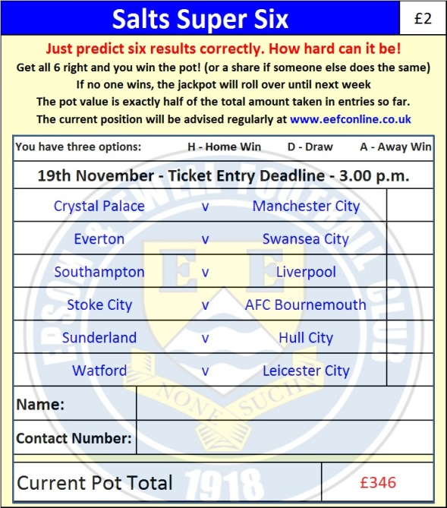

Good luck!

Combined Counties League – Premier Division
Saturday, 19th November 2016 - Kick-off 3.00 p.m.
Epsom and Ewell  (Royal Blue & White hoops) | V |  | Bedfont Sports  (Red & Black / Black)
Squad | NUMBERS
Michael Eacott |  |  | Billy Bishop
Reisse Griffin |  |  | James Grewenwood
Matt Tanton |  |  | Julius M’Ngadi
© Dan Dean |  |  | Billy Jefferys
Craig Hastings |  |  | Connagh Wilks
Alex McKay |  |  | Stave Brown
Rob Hendry |  |  | Paul Johnson
Matt Farrell |  |  | Connor Moody
Daryl Cooper-Smith |  |  | Matt Baxter
Savvas ‘Agi’ Panayiotou |  |  | Prince Mbengui
Matt Ferdinando |  |  | Olowula Akinsanya
Jordan Gallagher |  |  | Jimmy Hibbert
James Taylor |  |  | Simo Mbonkwi
Jason Nwachukwu |  |  | Christian Hurst
Daniel Rose |  |  | Scott Harris
Charlie Clark-Gleave |  |  | Lee Pearce
Alistair Turpie
Adam Heagney
Matt Smith
Glyn Mandeville | MANAGER |  | Paul Johnson
Matt Smith | ASSISTANT |  | Jimmy Hibbert / Gary Ross
Steve Eacott / Alex McKay / Jimmy Hendry | COACHES / PHYSIO |  | Dan Harvey
REFEREE: M.Hayden
ASSISTANTS: K.Parker, R.Redman
Today’s Match and Match Ball are sponsored by John Bonner

OUR NEXT VISITORS TO HIGH ROAD
A.F.C. Hayes
Combined Counties League – Premier Division
Saturday 26th November 2016 – 3.00 p.m.

